|  |  |
| --- | --- |
| **Name:** | Bhavik Maru |
| **Roll No & Branch:** | 31 CSE (DS) |
| **Class/Sem:** | BE/VII |
| **Experiment No.:** | 7 |
| **Title:** | To create an immersive environment (living room/ battlefield/ tennis court) with only static game objects. 3D game objects can be created using Blender or use available 3D models |

**Aim:** ToCreate an immersive environment (living room/ battlefield/ tennis court) with only static game objects

**Theory:**

**Augmented Reality (AR) and ARCore**

Augmented Reality (AR) is an interactive experience that combines the real world with computer-generated elements, enhancing the user's perception of reality. ARCore, developed by Google, is a powerful framework for building AR applications on Android devices.

**Plane Detection in ARCore**

Plane detection is a fundamental feature of ARCore. It allows the application to understand the physical environment by identifying flat surfaces such as floors, walls, and tabletops. ARCore accomplishes this by analyzing the visual features and patterns in the camera feed.

**Feature Points**

ARCore relies on identifying feature points in the environment. These are distinct visual cues like corners, edges, and other unique patterns. By tracking these points over time, ARCore constructs a 3D map of the environment.

**Surface Reconstruction**

Once feature points are detected, ARCore extrapolates surfaces from the points. These surfaces represent planes in the real world. This information is invaluable for anchoring virtual objects in the correct spatial context.

**Challenges in Plane Detection**

Surfaces with limited texture or uniform colors may pose challenges for accurate detection. In such cases, ARCore may have difficulty identifying feature points, potentially affecting the quality of plane detection.

**Depth API vs. Plane Detection**

While ARCore's Depth API provides a more detailed understanding of the environment, this lab focuses on Plane Detection for simplicity. Depth API offers enhanced spatial awareness, making it suitable for advanced AR applications.

**Procedure:**

1. Unity Project Setup

Open Unity or download the base project.

2. Add Plane Detection

Attach AR Plane Manager to AR Session Origin.

3. Create Picture Frame

Download 3D model and image, import to Asset folder.

4. Configure Picture Frame

Create "PictureFrame" GameObject with position and scale.

Set up 3D model as child with correct rotation.

5. Apply Material

Create "PictureFrameMaterial" and assign color.

Apply to 3D model.

6. Add Image

Adjust image settings (Texture Type, Pixels Per Unit).

Create child GameObject under "PictureFrame" and set scale.

7. Tag Picture Frame

Add "Spawnable" tag to "PictureFrame" GameObject.

8. Spawn Object

Create "SpawnableManager" script and attach.

Assign AR Session Origin and prefab.

9. UI Setup

Create "HidePlanesButton" and position.

Anchor elements and add "PlaneDetectionController" script.

10. Implement UI Interaction

Add event to button for "TogglePlaneDetection" method.

**Output:**

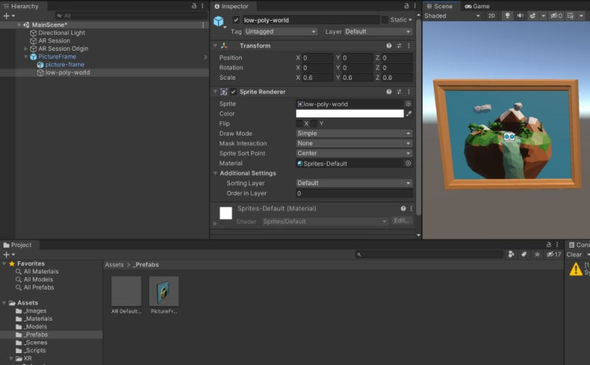

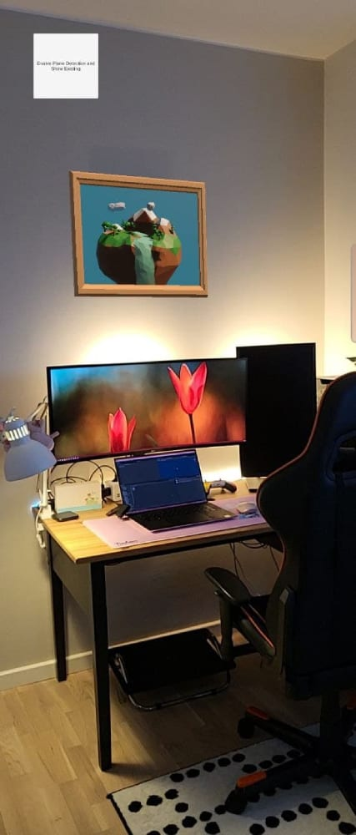

**Conclusion:**

This experiment showcased the implementation of ARCore's plane detection in Unity. The application successfully identifies vertical surfaces and overlays virtual objects. By utilizing feature points and surface reconstruction, accurate spatial awareness is achieved. This project serves as a stepping stone for creating more intricate and interactive AR experiences. It provides a solid foundation for future developments in augmented reality applications.